**Ex:02 Spring Core – Load Country from Spring Configuration XML**

**PROGRAM:**

package com.cognizant.spring_learn;  
import org.slf4j.Logger;  
import org.slf4j.LoggerFactory;  
import org.springframework.context.ApplicationContext;  
import org.springframework.context.support.ClassPathXmlApplicationContext;  
  
public class SpringLearnApplication {  
  
private static final Logger *LOGGER* = LoggerFactory.*getLogger*(SpringLearnApplication.class);  
  
public static void main(String[] args) {  
*LOGGER*.info("START");  
  
*displayCountry*();  
  
*LOGGER*.info("END");  
 }  
  
public static void displayCountry() {  
ApplicationContext context = new ClassPathXmlApplicationContext("country.xml");  
com.cognizant.springlearn.Country country = context.getBean("country", com.cognizant.springlearn.Country.class);  
*LOGGER*.debug("Country : {}", country);  
 }  
}

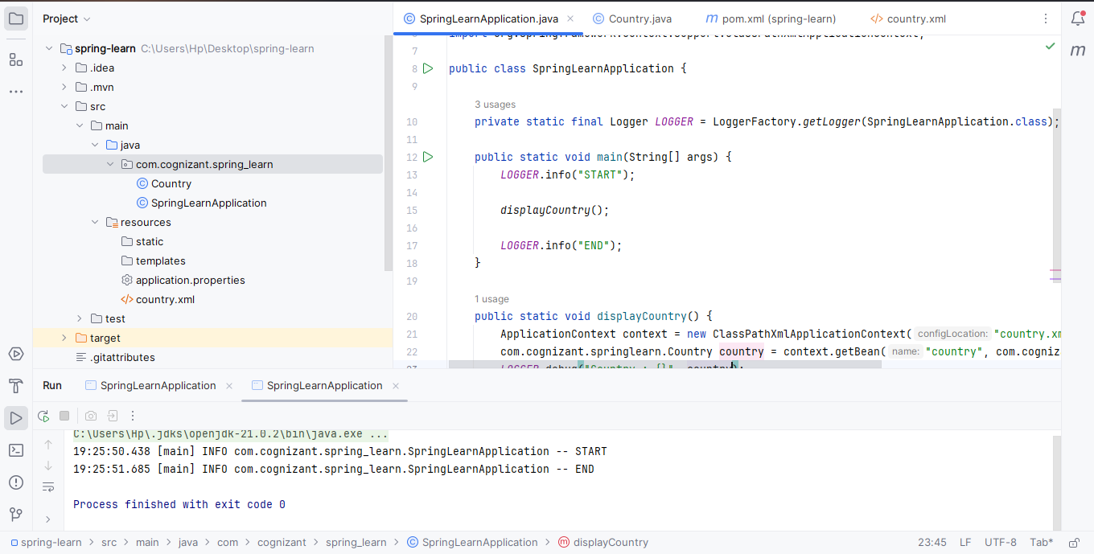

package com.cognizant.springlearn;  
  
import org.slf4j.Logger;  
import org.slf4j.LoggerFactory;  
  
public class Country {  
private static final Logger *LOGGER* = LoggerFactory.*getLogger*(Country.class);  
  
private String code;  
private String name;  
  
public Country() {  
*LOGGER*.debug("Inside Country Constructor.");  
 }  
  
public String getCode() {  
*LOGGER*.debug("Inside getCode()");  
return code;  
 }  
  
public void setCode(String code) {  
*LOGGER*.debug("Inside setCode()");  
this.code = code;  
 }  
  
public String getName() {  
*LOGGER*.debug("Inside getName()");  
return name;  
 }  
  
public void setName(String name) {  
*LOGGER*.debug("Inside setName()");  
this.name = name;  
 }  
  
@Override  
public String toString() {  
return "Country [code=" + code + ", name=" + name + "]";  
 }  
}